**336 - The Cell Phone Turns 40**

[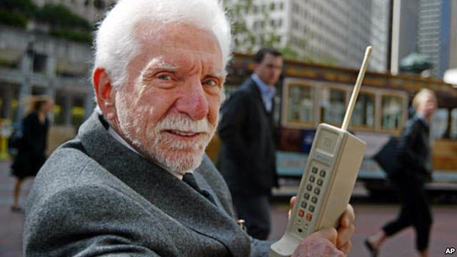](http://gdb.voanews.com/0665394D-EC34-49BD-9BCB-970239A86947_mw1024_n_s.jpg)

Martin Cooper, pictured here in 2003, holds the original model of the protype phone he used to make the first ever cell phone call in 1973.

Forty years ago today the cell phone era began on the streets of New York City. The historic first cell phone call was made by [Martin Cooper](http://en.wikipedia.org/wiki/Martin_Cooper_%28inventor%29), director of systems operations for the communications division of the [Motorola](http://www.motorola.com/us/consumers/home) company, to his main rival at [Bell Labs](http://www3.alcatel-lucent.com/wps/portal/belllabs).  
  
Martin described his call to Bell’s Dr. Joel S. Engel on April 3, 1973 in an article called [*The History of the Cell Phone*](http://www.thehistoryof.net/history-of-cell-phones.html)by Gareth Marples.  
  
**Talking while walking**  
  
“As I walked down the street while talking on the phone, sophisticated New Yorkers gaped at the sight of someone actually moving around while making a phone call,” Martin wrote. “Remember that in 1973, there weren't cordless telephones or cellular phones. I made numerous calls, including one where I crossed the street while talking to a New York radio reporter - probably one of the more dangerous things I have ever done in my life.”  
  
[A 1973 press release](http://demandware.edgesuite.net/aahb_prd/on/demandware.static/Sites-Motorola_US-Site/Sites-Motorola_US-Library/en_US/v1365011292177/corporate/about-us/docs/Motorola-Heritage-DynaTAC-NewsRelease.pdf), Motorola touted its new [Dyna-Tac](http://demandware.edgesuite.net/aahb_prd/on/demandware.static/Sites-Motorola_US-Site/Sites-Motorola_US-Library/en_US/v1365011292177/corporate/about-us/docs/Motorola-Heritage-DynaTAC-facts.pdf) “portable radio telephone,” saying it would operate over radio frequencies and “talk” to any conventional ([landline](http://en.wikipedia.org/wiki/Landline)) telephone in the world.  
  
“What this means, said John F. Mitchell, manager of Motorola’s communications division, is that in a city where the Dyna-Tac system is installed, it will be possible to make telephone calls while riding in a taxi, walking down the city’s streets, sitting in a restaurant or anywhere else a radio signal can reach.”  
  
The new Motorola mobile phone was nicknamed [“the brick”](http://www.retrobrick.com/moto8000.html) since it was about the size of a brick used in building houses.  It weighed about one kilogram and it measured 22.86cm x 17.7cm x 4.44cm.  The talk time of the phone was fairly short since its batteries only provided a charge for about 35 minutes and took about 10 hours to recharge.  
  
Motorola had been perfecting its new invention for about 10 years when it commercially introduced a slimmer [Dyna-Tac 8000X](http://www.wirelessmuseum.org/archives/134) “brick” in 1983.  Motorola trimmed the weight down to less than half a kilogram and sold for $3,995.  
  
**Phones have changed**x

[](http://gdb.voanews.com/408260AC-A22B-488F-89DF-B88274CDBED5_mw1024_n_s.jpg)

Woman using a modern “smartphone” (Public Domain via Pixabay)

Technology for the mobile phone has advanced quite rapidly since then, with bigger and more sophisticated cellular networks being developed and built, and the phones themselves evolving into multifunctional [“smartphones”](http://en.wikipedia.org/wiki/Smartphone) that provide internet access, along with other features such a built-in cameras, portable music players and video playback.  
   
The number of mobile phone subscribers has skyrocketed over the years, with about 340, 213 in 1985, according to the trade organization [CTIA, the Wireless Association](http://www.ctia.org/), to more than six billion today, according to a [telecom report released by the United Nations](http://www.itu.int/net/pressoffice/press_releases/2012/70.aspx#.UVx0e6zheSo) last October.  
  
Today increasing numbers of people are getting rid of their traditional landline phone service in favor of using their mobile phones as their sole form of telephone communications.  In a number of developing countries that didn’t have much of a landline infrastructure to begin with, communications companies skipped over installing cumbersome and expensive landline system and instead invested in and developed their own massive mobile phone/cellular phone systems.

**336 – vragen bij de tekst**  
  
1. Lees de titel en de kopjes van de tekst. Waar denk je dat de tekst over gaat?  
…………………………………………………………………………………………………………………………………………………………….  
…………………………………………………………………………………………………………………………………………………………….  
…………………………………………………………………………………………………………………………………………………………….  
  
2. Wie voerden het eerste mobiele telefoongesprek. Hoe kenden ze elkaar?  
…………………………………………………………………………………………………………………………………………………………….  
…………………………………………………………………………………………………………………………………………………………….  
  
3. Hoe reageerden mensen toen ze voor het eerst iemand mobiel zagen bellen?  
…………………………………………………………………………………………………………………………………………………………….  
…………………………………………………………………………………………………………………………………………………………….  
…………………………………………………………………………………………………………………………………………………………….  
  
4. Leg in 10 woorden uit hoe het Dyna-Tac systeem werkt.  
…………………………………………………………………………………………………………………………………………………………….  
…………………………………………………………………………………………………………………………………………………………….  
  
5. Wat was de bijnaam van de eerste mobiele telefoon. Hoe kwam het aan deze bijnaam?  
…………………………………………………………………………………………………………………………………………………………….  
…………………………………………………………………………………………………………………………………………………………….  
  
6. *“The number of mobile phone subscribers has skyrocketed over the years…”*  
Wat betekent “skyrocketed”?  
…………………………………………………………………………………………………………………………………………………………….  
…………………………………………………………………………………………………………………………………………………………….  
  
7. In ontwikkelingslanden is de mobiele telefoon ook erg populair. Waarom is dat?  
…………………………………………………………………………………………………………………………………………………………….  
…………………………………………………………………………………………………………………………………………………………….…………………………………………………………………………………………………………………………………………………………….